Topic 4.10

ORGANIC SYNTHESIS AND ANALYSIS

Organic analysis
Organic synthesis

DISTINGUISHING BETWEEN DIFFERENT ORGANIC COMPOUNDS

Many of the organic compounds prepared in AS Unit 2 and in A2 Unit 4 can be distinguished by means of simple chemical tests. A number of these distinguishing tests will be discussed in this chapter.

a) test for alkenes

Alkenes decolorize bromine water because they undergo an electrophilic addition reaction with bromine:

Add a few drops of bromine water to the sample and shake. If the bromine decolorizes, an alkene is present. If not, no alkene is present.

b) test for haloalkanes

When haloalkanes are heated with dilute sodium hydroxide, a nucleophilic substitution reaction occurs and halide ions are produced. The halide ions can be identified using the tests described in AS Unit 2:

Add aqueous sodium hydroxide to the sample and heat. Then allow to cool, add dilute nitric acid and then aqueous silver nitrate. A white precipitate soluble in dilute ammonia indicates that a chloroalkane was present, a cream precipitate soluble in concentrated ammonia indicates that a bromoalkane was present, and a yellow precipitate insoluble in ammonia indicates that an iodoalkane was present.

c) test for aldehydes

Aldehydes can be oxidized by mild oxidizing agents such as Fehling’s solution or Tollen’s reagent.

Add Tollen’s reagent to the sample and heat. A silver mirror indicates the presence of an aldehyde.

Or

Add Fehling’s solution to the sample and heat. A brick-red precipitate indicates the presence of an aldehyde.

d) test for carboxylic acids

Carboxylic acids are acids and can liberate carbon dioxide from carbonates:

Add sodium carbonate solution to the sample. If effervescence is seen, and the gas produced turns limewater milky, a carboxylic acid is present.

e) test for acyl chlorides

Acyl chlorides release chloride ions very readily to give hydrogen chloride gas.

Add water to the sample slowly. If white misty fumes are given off, an acyl chloride is present.

f) test for amines

Amines are basic.

Add universal indicator to the sample. If it turns blue/purple an amine is present. It will also have a fishy smell.

g) test for alcohols

Alcohols react with carboxylic acids in the presence of sulphuric acid to make esters.

Add ethanoic acid to the sample, followed by sulphuric acid and heat. If a the mixture starts smelling sweet and fruity an alcohol was present.

h) distinguishing tests for primary, secondary and tertiary alcohols

Primary alcohols can be oxidized to form aldehydes. Secondary alcohols are oxidized to form ketones. Tertiary alcohols cannot be oxidized.

Add potassium dichromate and dilute sulphuric acid to the mixture and warm gently.
If the mixture goes green a primary or secondary alcohol is present. If it does not go green a tertiary alcohol is present. If the mixture does go green, add Fehling’s solution to the mixture and heat. If a brick-red precipitate if formed then a primary alcohol was present. If no brick-red precipitate is formed then a secondary alcohol was present.

ORGANIC SYNTHESIS

It is possible to make a large number of organic products from a few starting compounds and the necessary reagents. The following organic pathways are required for Unit 4:

1. alkane → chloroalkane

reagents: chlorine
conditions: UV light
equation: CH₄ + Cl₂ → CH₃Cl + HCl (example)

NB This reaction introduces a new functional group onto the molecule

2. chloroalkane → alcohol

reagents: aqueous NaOH
conditions: warm, reflux
equation: R-Cl + NaOH → R-OH + NaCl

3. chloroalkane → alkene

reagents: alcoholic KOH
conditions: heat, distillation
equation: CH₃CH₂Cl + KOH → CH₂=CH₂ + KCl + H₂O (example)

4. chloroalkane → nitrile

reagents: aqueous KCN
conditions: heat, reflux
equation: R-Cl + KCN → R-CN + KCl

NB This reaction introduces an extra carbon atom onto the molecule

5. chloroalkane → primary amine

reagents: excess ammonia
conditions: heat
equation: R-Cl + 2NH₃ → R-NH₂ + NH₄Cl

6. primary amine → secondary amine

reagents: chloroalkane
conditions: warm
equation: R₁-NH₂ + R₂-Cl → R₁R₂NH + HCl
7. secondary amine → tertiary amine

reagents: chloroalkane
conditions: warm
equation: R₁R₂NH + R₃-Cl → R₁R₂R₃N + HCl

8. tertiary amine → quartenary ammonium salt

reagents: chloroalkane
conditions: warm
equation: R₁R₂R₃N + R₄-Cl → R₁R₂R₃R₄N⁺Cl⁻

9. alkene → alkane

reagents: hydrogen, Ni catalyst
conditions: 150 ºC, 2 atm
equation: CH₂=CH₂ + H₂ → CH₃CH₃ (example)

10. alkene → dibromoalkane

reagents: bromine
conditions: room temperature
equation: CH₂=CH₂ + Br₂ → CH₂BrCH₂Br (example)

NB This reaction introduces a new functional group onto the molecule

11. alkene → bromoalkane

reagents: hydrogen bromide
conditions: room temperature
equation: CH₂=CH₂ + HBr → CH₃CH₂Br (example)

12. alkene → alkylhydrogensulphate

reagents: concentrated sulphuric acid
conditions: cold
equation: CH₂=CH₂ + H₂SO₄ → CH₃CH₂OSO₃H (example)

13. alkylhydrogensulphate → alcohol

reagents: water
conditions: warm
equation: CH₃CH₂OSO₃H + H₂O → CH₃CH₂OH + H₂SO₄ (example)
14. alkene → alcohol

reagents: steam
conditions: 300 ºC, 600 kPa, phosphoric acid catalyst
equation: CH₂=CH₂ +H₂O → CH₃CH₂OH

15. nitrile → primary amine

reagents: LiAlH₄
conditions: dry ether
equation: R-CN + 4[H] → R-CH₂NH₂ (example)

16. nitrile → carboxylic acid (not examinable)

reagents: dilute HCl
conditions: heat under reflux
equation: R-CN + 2H₂O + HCl → R-COOH + NH₄Cl

17. alcohol → alkene

reagents: concentrated sulphuric acid
conditions: heat, reflux
equation: CH₃CH₂OH → CH₂=CH₂ + H₂O (example)
18. primary or secondary alcohol → carbonyl

reagents: potassium dichromate and dilute sulphuric acid
conditions: warm, distillation
equation: R₁R₂CHOH + [O] → R₁-COR₂ + H₂O

19. primary alcohol → carboxylic acid

reagents: potassium dichromate and dilute sulphuric acid
conditions: heat, reflux
equation: R-CH₂OH + 2[O] → R-COOH + H₂O

20. aldehyde → carboxylic acid

reagents: potassium dichromate and dilute sulphuric acid
conditions: heat, reflux
equation: R-CHO + [O] → R-COOH

21. carbonyl → alcohol

reagents: NaBH₄(aq)
conditions: room temperature
equation: R₁-COR₂ + 2[H] → R₁R₂CHOH

22. carboxylic acid → carboxylate salt

reagents: NaOH
conditions: room temperature
equation: R-COOH + NaOH → R-COONa + HO

23. amine → alkylammonium salt

reagents: HCl(aq)
conditions: room temperature
equation: R₁R₂R₃N + HCl → R₁R₂R₃NHCl

24. carbonyl → hydroxynitrile

reagents: HCN
conditions: room temperature
equation: R₁COR₂ + HCN → R₁R₂COHCN

NB This reaction adds an extra carbon atom and introduces an extra functional group onto the molecule
25. acyl chloride → carboxylic acid

reagents: water
conditions: room temperature
equation: R-COCl + H₂O → R-COOH

26. acyl chloride → amide

reagents: ammonia
conditions: room temperature
equation: R-COCl + NH₃ → R-CONH₂

27. acid anhydride → carboxylic acid

reagents: water
conditions: warm
equation: (RCO)₂O + H₂O → 2R-COOH

28. acid anhydride → amide

reagents: ammonia
conditions: warm
equation: (RCO)₂O + NH₃ → R-CONH₂ + RCOOH

29. carboxylic acid + alcohol → ester

reagents: concentrated sulphuric acid
conditions: heat, reflux
equation: R₁COOH + R₂OH → R₁COOR₂ + H₂O

30. acyl chloride + alcohol → ester

conditions: room temperature
equation: R₁COCl + R₂OH → R₁COOR₂ + HCl

31. acid anhydride + alcohol → ester

conditions: warm
equation: (R₁CO)₂O + R₂OH → R₁COOR₂ + R₁COOH

32. ester → carboxylic acid + alcohol

reagents: concentrated sulphuric acid
conditions: heat under reflux
equation: R₁COOR₂ + H₂O → R₁COOH + R₂OH

33. ester → carboxylate salt + alcohol

reagents: NaOH(aq)
conditions: heat under reflux
equation: R₁COOR₂ + NaOH → R₁COONa + R₂OH

34. acyl chloride + primary amine → N-substituted amide

conditions: room temperature
equation: R₁-COCl + 2R₂-NH₂ → R₁-CONHR₂ + R₂-NH₃Cl

35. acid anhydride + primary amine → N-substituted amide

conditions: warm
equation: (R₁CO)₂O+ R₂-NH₂ → R₁-CONHR₂ + R₁-COOH

36. benzene → nitrobenzene

reagents: concentrated sulphuric and nitric acids
conditions: warm, reflux
equation: C₆H₆ + HNO₃ → C₆H₅NO₂ + H₂O

37. benzene → alkylbenzene

reagents: chloroalkane, AlCl₃
conditions: warm, reflux
equation: C₆H₆ + RCl → C₆H₅R + HCl

38. benzene → phenylalkanone

reagents: acyl chloride, AlCl₃
conditions: room temperature
equation: C₆H₆ + RCOCl → C₆H₅COR + HCl

39. nitrobenzene → phenylamine

reagents: tin, concentrated HCl
conditions: room temperature
equation: C₆H₆ + 6[H] → C₆H₅NH₂ + 2H₂O

The interconversion of these compounds can be summarised in the following synthesis maps:

a) aliphatic synthesis map – simple conversions

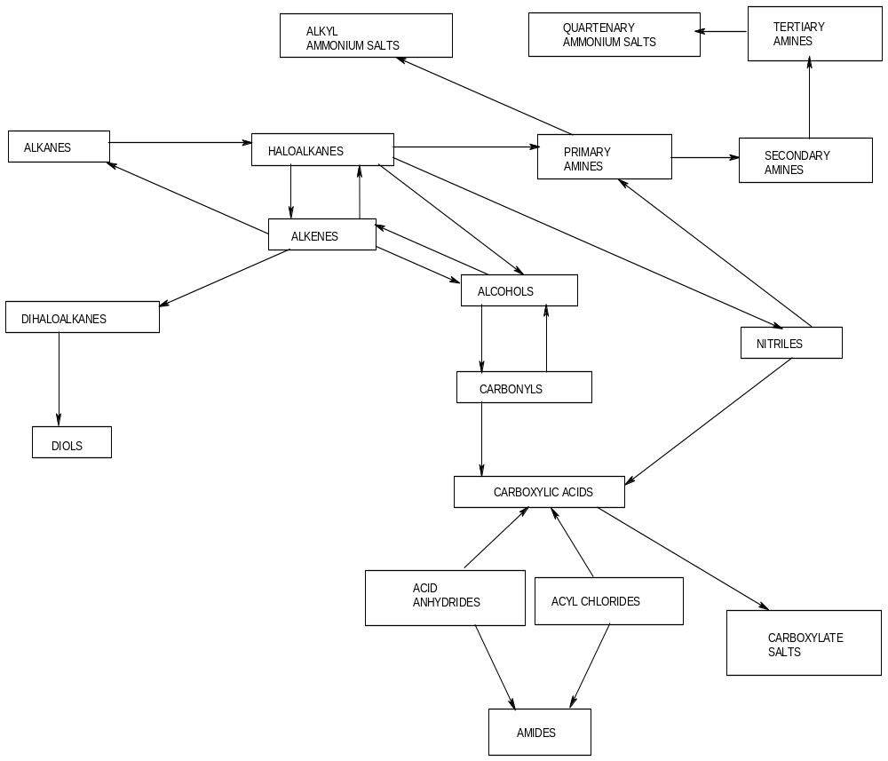
b) condensation reactions

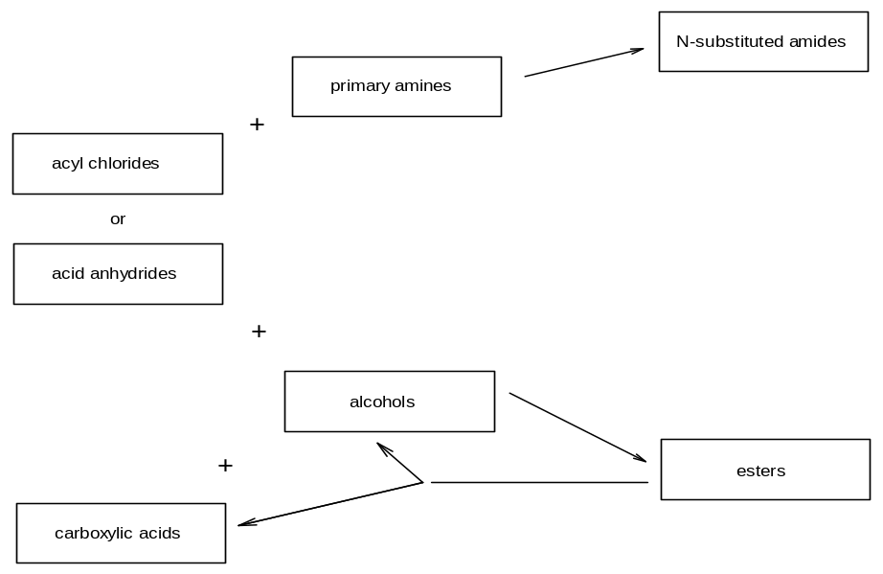

c) aromatic conversions

